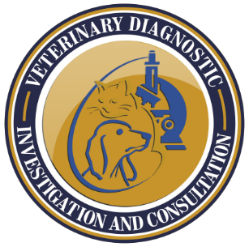
David Bruyette, DVM, DACVIM (SAIM)
Veterinary Diagnostic Investigation and Consultation
14 Morgan Rd
Bell Canyon, CA 91307
www.veterinarydiagnosticinvestigation.com
(c) 310-482-1268
davebruyette@aol.com

Internal Medicine Consultation
Date:
Expert Veterinary Internal Medicine and Endocrinology Consulting Services
Pets Name:
Clients Name:

Referring Veterinarian:
Referring Veterinarian Email:
Referring Veterinarian Phone:

Signalment:
Weight:

Indication for Consultation:

History:

Please upload all your case information (request form, medical records, imaging) using the link below.

https://www.veterinarydiagnosticinvestigation.com/submit-case

You can also send the files directly to: Davebruyette@aol.com

The following have been submitted:
Consult Request: Yes No
Medical Records: Yes No
Images: Yes No
Do not hesitate to call me (310-482-1268) if you have any questions and thanks for allowing me to be part of your diagnostic team!

Dave

